Form W-4 Options

To review your current form W-4 set-up, please go to the Employee Dashboard Tile in MyPortal.

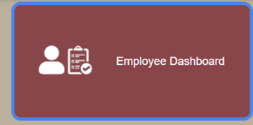
- Click on the Employee Dashboard Tile

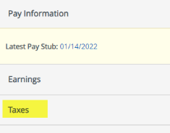
- Next, click on Taxes

Current Federal and State Income Tax Withholding selections are listed on the left:

