Revised 03.04.2024

Budget Transfers
- User will need to be on-campus OR using the College’s VPN service.
- In MyPortal, Click “Banner Admin Pages”
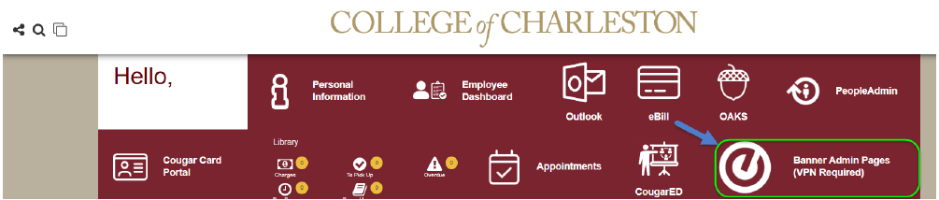

- In Banner Admin Pages, go to the Budget Entry screen by typing “Journal Voucher Mass Entry” in the search box
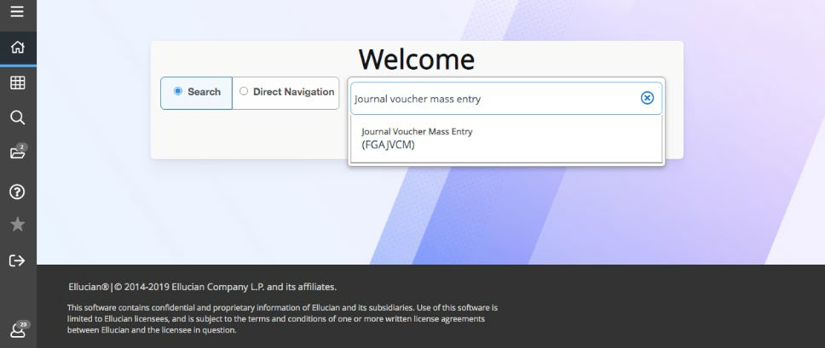

- For new budget transfer entries, leave the document number blank, and click “Go”
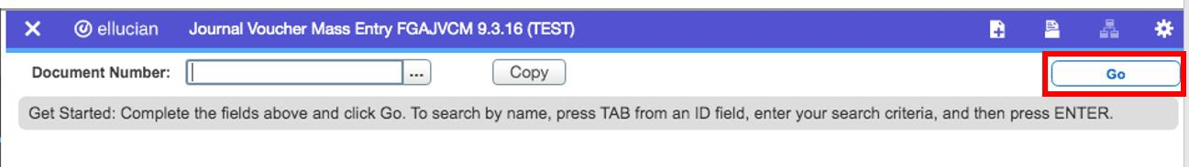

- Entering a new budget transfer
  - Journal Voucher Document Header
    - Transaction will default to the current date
    - Enter the document total, which will be the absolute value of the transfer.
      - For example, moving $500 from 71010 to 72010, will require one line for the minus and one line for the plus, which would result in a document total of $1,000.
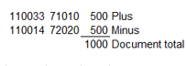

  - Default Values Section
    - Allows the end-user to enter items that will populate on every transfer line
    - Always enter “01” for Budget Period
    - You will need to enter BD02 for Permanent/Recurring Transfer or BD04 for a Temporary transfer, if the transfers will all be the same type
    - If you want the same description for each transfer line, enter this in the “Description” box
      - Limited to 23 characters, spaces included
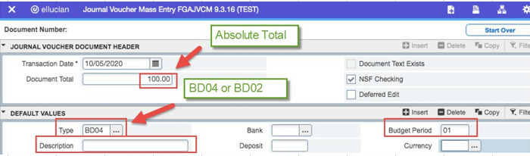

- Journal Voucher Detail
  - Important Notes
    - Only whole numbers can be transferred. Please round up or round down on the transfer amounts.
    - For the most part, budget transfers occur between the five-digit pool accounts.
    - Most common account numbers for end-user budget transfers: 610211 Temporary Positions, 61030 Student Employment, 71010 Contractual Services, 72010 Supplies, 73010 Travel, 74010 Fixed Charges.
    - Only the Budget Office processes transfers from 610111 Unclassified Positions and 610210 Classified Positions. If the Index starts with “1”, on the Budget Office processes transfers involving 62000 Fringe.
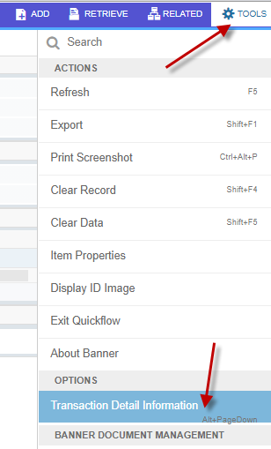
    - Budget transfers can only occur between Indexes with the same fund. Indexes that start with a “1” all have the same fund, 110001.
    - End-users will only be able to enter transfers under their security level. Transfers between security levels (i.e. School of Business to Financial Aid) will need to be requested to the Budget Office.
    - Budget entries must net zero. i.e. the “plus” entries and the “minus” entries must equal zero.
  - To get to the Journal Voucher Detail section from Default Values, press the shortcut Alt+PageDown OR at the top right of the screen, Tools – Transaction Detail Information

  - Do not enter the Seq (sequence) number as it will automatically populate.
  - Use the tab or mouse to move to the cells. Items that need to be entered:
    - Type: BD04 (Temporary) or BD02 (Permanent)
    - Index
    - Account
    - Amount
v. +Plus or -Minus
- Description (up to 23 characters)
- Budget Period – 01
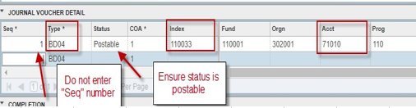

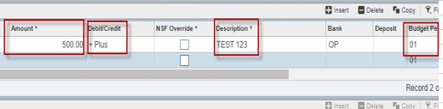

  - To go to the next row – Use the “down arrow” on your keyboard and enter your information.
  - Once all the transfer lines are entered, click “Save” at the bottom right hand corner.
  - After your transfers are saved send an email to Budget@cofc.edu in the following format –
    - The following transfer(s) have been saved and are ready for approval:
      - J0XXXXXX
      - J0XXXXXX
      - J0XXXXXX

